<COMPANY LOGO GOES HERE>

Standard Operating Procedure (SOP)

For: Outline the task and its purpose. Examples: Entering a sale in quickbooks, creating a newsletter, hiring new staff etc. These are intended for the simplest to the most difficult tasks.

Frequency: Indicate how often the task should be done. If on a specific date identify this here.

Assigned to:. To be completed by whom

*Pretend you are a new employee that has never completed this task and provide a detailed description of the steps along with diagrams, screenshots where necessary.

Procedure: (example)

- Log into Facebook at www.Facebook.com using the login: abcde@ghij.com and password: abc123
- Find shortcuts on the left-side of the screen (if using a laptop) and select the Entrepreneurial Edge.
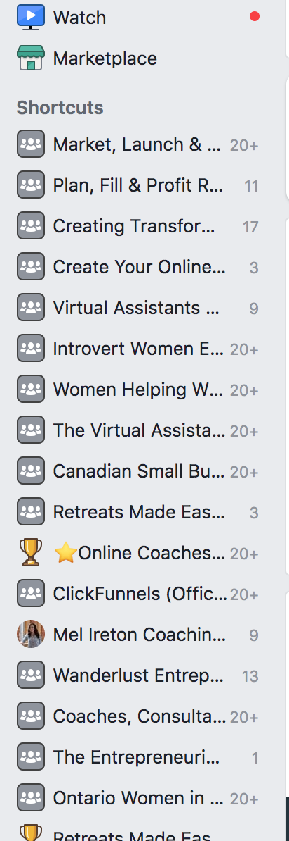

- Select The Entrepreneurial Edge Group by double clicking on the group name. The group will open.
- Etc. etc. etc.

Video Link: I like to do a loom video to show staff how to complete tasks and I find this very helpful for my clients as well when they are visual so always give the video link as an option where possible.

Created By:
Last Reviewed: Insert the creation date. If the document is every updated be sure to update the date so everyone knows the information is current.

**NOTES: This document is used to create uniformity, organization and a level of professionalism with the organization. Keep in mind that you may need to add definitions if there is a possibility that a new person would not know the information.. Be as detailed and informative as possible.
If the SOP involved sending emails or messages write out the content of those emails and messages so that this can be a smooth process.
Every Business will appreciate having this process on a google drive where access can be granted to anyone needing it. It also shows a very high level of professionalism from you as a VA.
If you have any questions feel free to email me at meliretoncoaching@gmail.com and register for other updated and important Business tips and tools in my Facebook Group The Entrepreneurial Edge.
Have a great day!
Mel

